Rancho Goleta Lakeside Solar Microgrid Project

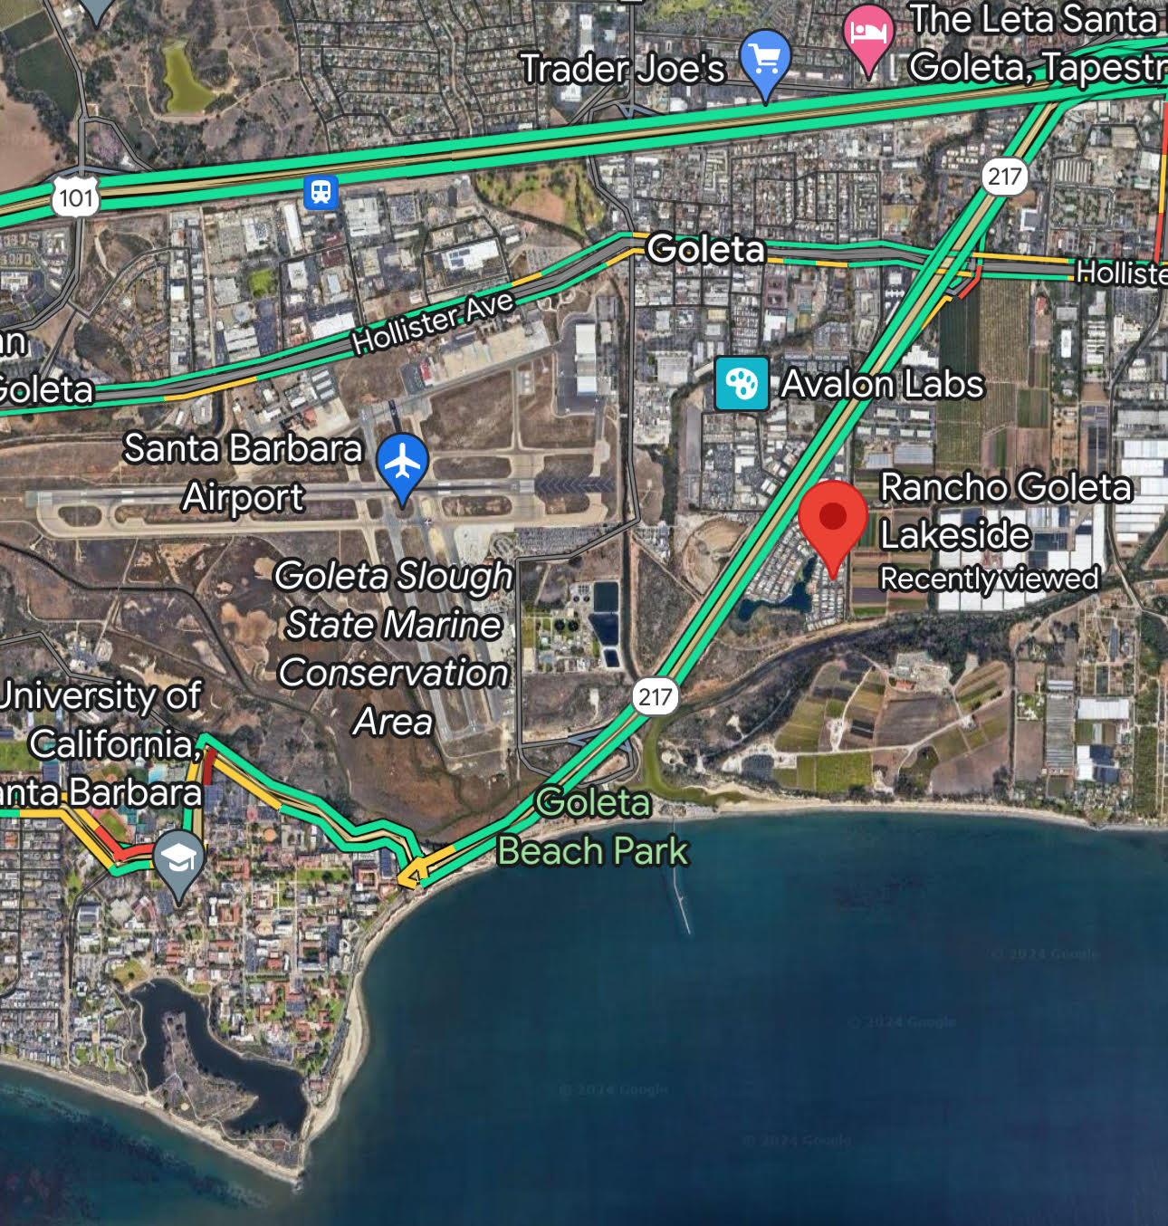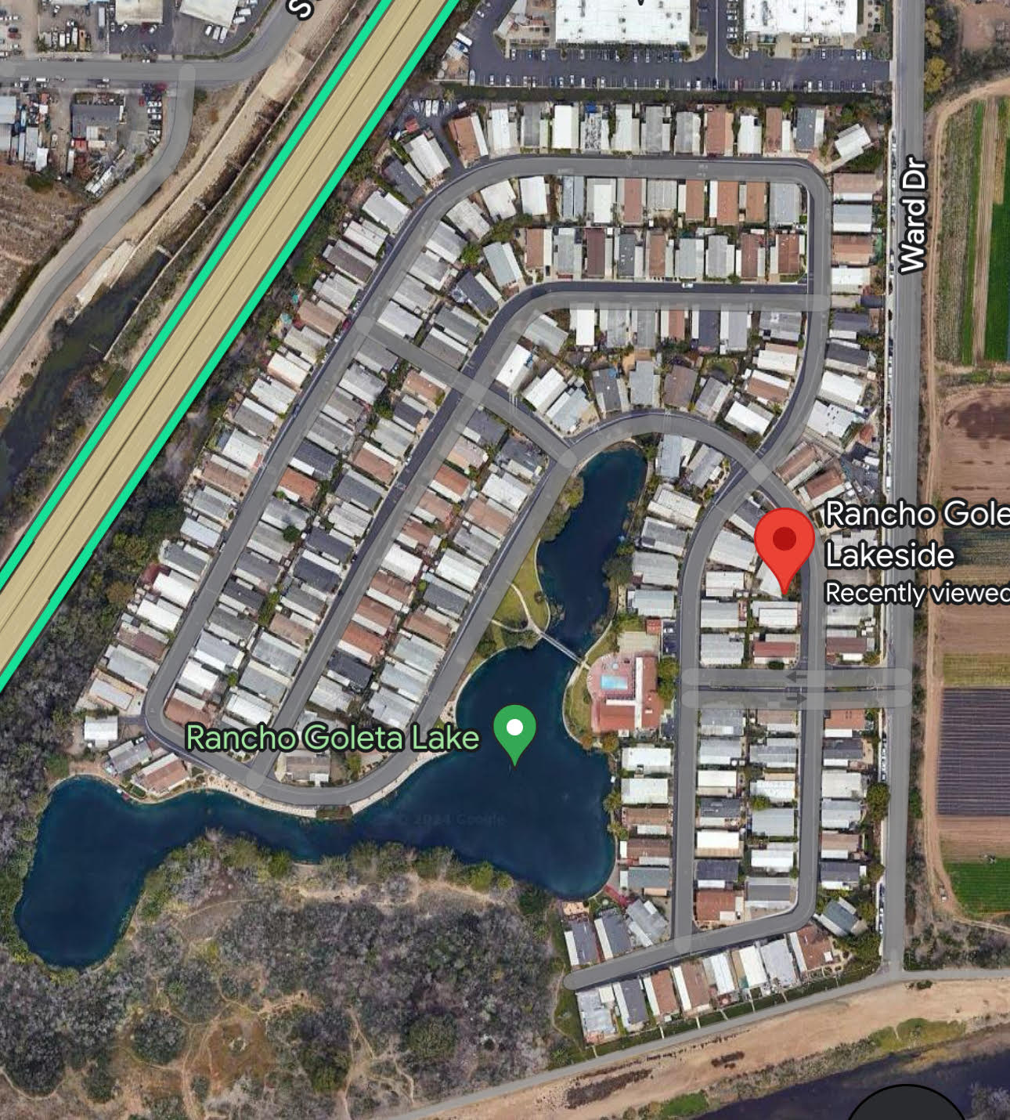

Presented to the California Public Utilities Commission in response to the Clean Equity Access Grant Program

Submitted by
Clean Coalition

30 April 2024

Table of Contents
Executive Summary 3
Organization Background And Qualifications 6
Project Need 11
Evaluation and Data Collection 14
Community Engagement Plan 18
Workplan 19
Budget 19

Executive Summary
Describe the targeted community or tribal government, the project’s geographic location, high-level relevant demographic data, the project and project goals, and the reasons why the project will benefit the targeted community.
The Clean Coalition has partnered with Rancho Goleta Lakeside Mobileers Inc. (“RGL”) in developing a Solar Microgrid to serve its community. The project is titled the “RGL Solar Microgrid”.

RGL is a nonprofit mutual benefit corporation and an owner-occupied residential community consisting of 200 homes, having been built from 1970-2024, all served by a single Southern California Edison (SCE) master meter. The existing RGL electrical infrastructure includes nearly two miles of RGL-owned & operated underground distribution grid that is significantly constrained. Each home is privately submetered with private monthly billing to ensure that each home is responsible for the cost of its own energy use – and to ensure that all RGL community members are financially motivated to conserve energy.

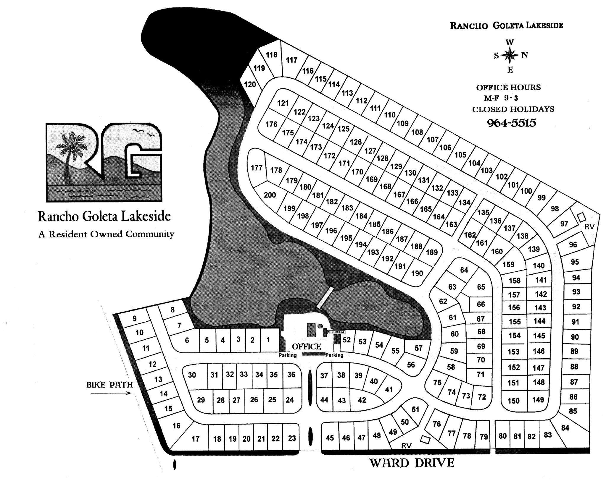
Figure 1: RGL community consisting of 200 mobile homes
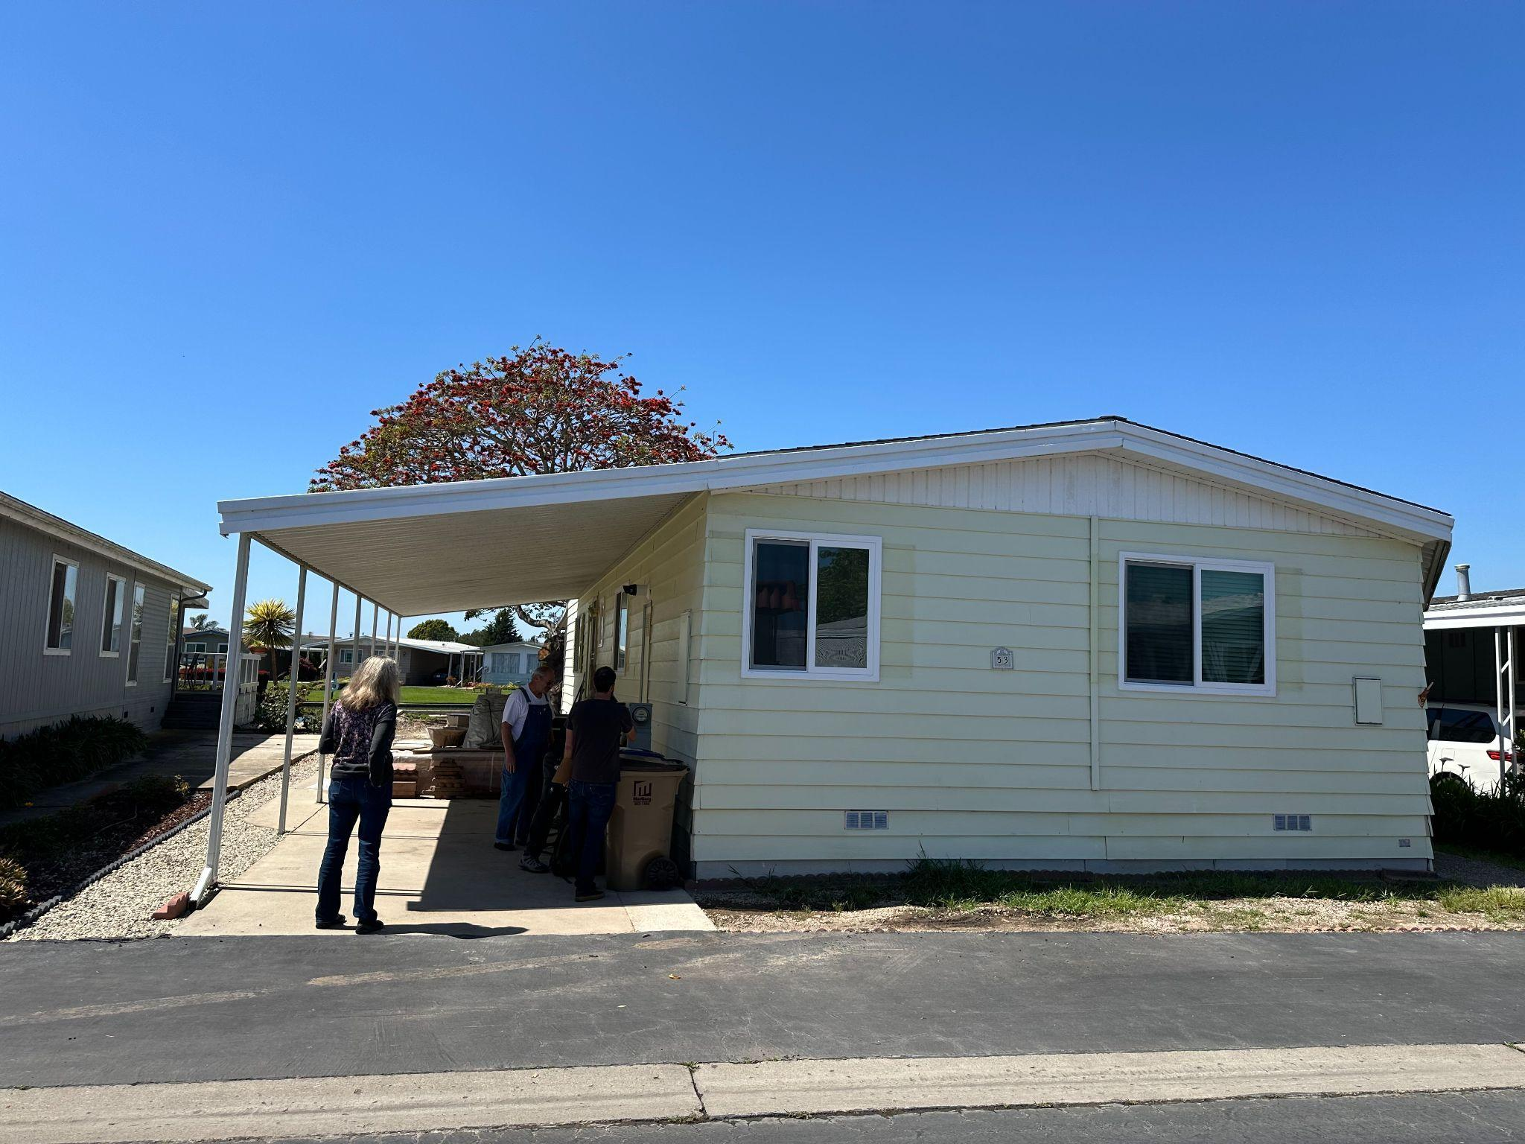
Figure 2: Typical RGL mobile home

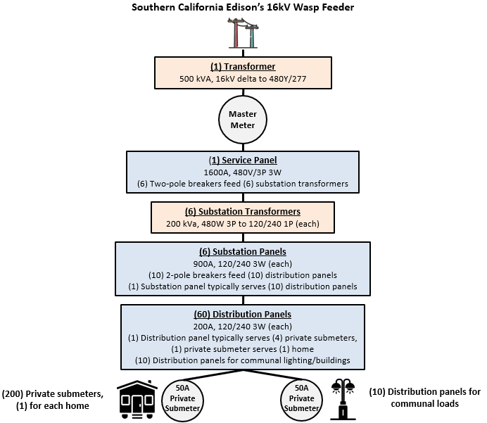
Figure 3: Diagram of RGL electrical infrastructure

RGL is located on approximately 28 acres within the City of Goleta and is the only disadvantaged community in the entire Goleta Load Pocket (GLP) region (see Figure 3). The GLP is a disaster-prone and transmission-vulnerable 70-mile stretch of coastline in Southern California (see Figure 4). It extends from Point Conception to Lake Casitas and encompasses the cities of Goleta, Santa Barbara (including Montecito), and Carpinteria.

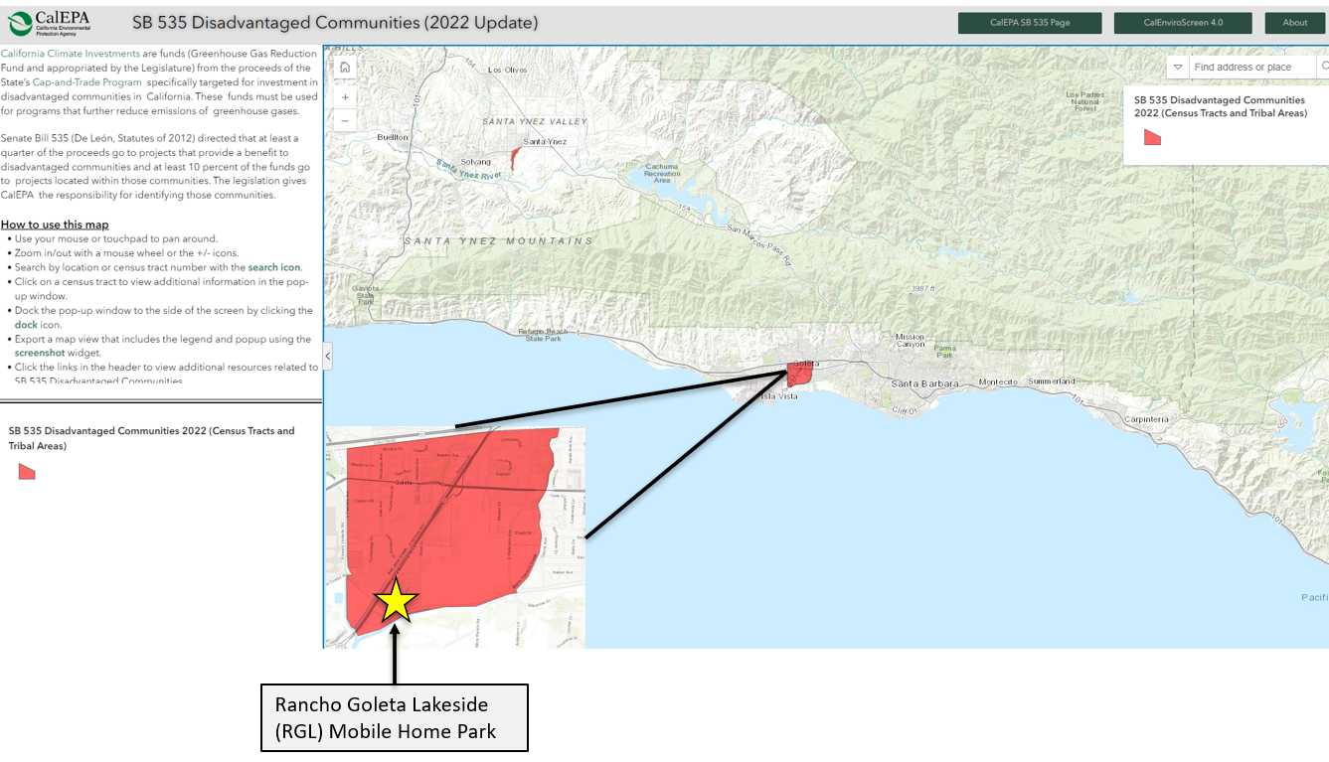
Figure 4: This map shows RGL in a disadvantaged community designated by CalEPA for the purpose of SB 535. This area represents a 25% highest scoring census tract in CalEnviroScreen 4.0 – the only disadvantaged community in the entire GLP region.

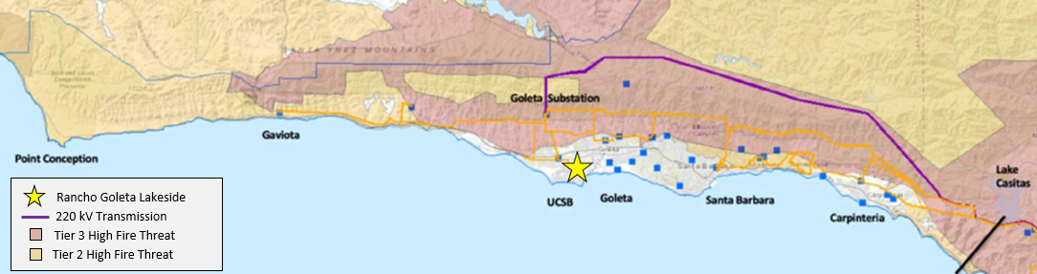
Figure 5: Map of the GLP, showing the RGL site location and high fire threat areas in red and orange

The Clean Coalition and the RGL community are excited about the environmental benefits of a solar-driven community, along with the many other advantages offered by the RGL Solar Microgrid. These benefits include:

- Solar-driven resilience, based on the Clean Coalition’s load-tiering and value-of-resilience (VOR) approach: VOR123.
- Standardization of the Solar Microgrid on the carports and veranda.
- Solar-driven electrification for Electric Vehicle (EV) charging; heat pumps for Heating, Ventilation and Air Conditioning (HVAC), hot water, and pool heating; induction cooktops; and electric dryers; etc.

The Clean Coalition will provide a standardized model for how mobile homes can include Solar Microgrids for any and all locations where this type of housing is installed. The RGL Solar Microgrid will create the opportunity for substantial solar photovoltaics (“solar”), energy storage, and electrification upgrades via dispatchable self-generated solar energy, in a manner that will be a showcase for what is possible at housing communities across California – and well beyond.

Beyond the clear economic, environmental, and resilience benefits that the RGL Solar Microgrid offers its residents and the surrounding area, it serves as a perfect case study for policy innovations that will allow Master Metering at all types of multi-unit housing communities, to ensure they can benefit from the economic, environmental, and resilience benefits of Solar Microgrids. Traditionally, these facilities have multiple electric meters, making it impossible to incorporate Solar Microgrids due to California’s existing legal prohibition on residential Master Metering.

SB 1148, a 2024 legislative attempt to allow MUH facilities to master meter in order to benefit from Solar Microgrids was unsuccessful, the awareness for a need to be able to master meter is growing fast, and the RGL Solar Microgrid will help build on the awareness.

Currently, mobile home park sites like RGL are the only facilities permitted for Master Metering. Hence, the RGL Solar Microgrid project will serve as a powerful example that informs policymakers about the critical need for Master Metering at residential communities. A robust Case Study will be created around the RGL Solar Microgrid to help pave the way.

Organization Background And Qualifications
Provide a summary of the applicant’s: (A) Organization background and primary mission; (B) History of working with the targeted community and local stakeholder relationships that may lead to the project’s success; and (C) Demonstrated experience with planning and implementing community programs.
Clean Coalition: The Clean Coalition is a sponsored project of Natural Capitalism Solutions, Inc. — a nonprofit 501c3 organization. The Clean Coalition is based in California and whose mission is to accelerate the transition to renewable energy and a modern grid through technical, policy, and project development expertise. The Clean Coalition envisions the United States being 100% powered by renewable energy, substantially from local sources. In this pursuit, Clean Coalition has managed over $10,000,000 in grants and contracts that increase renewable energy and decrease air pollutant emissions in collaboration with various partners such as: California Energy Commission, Northern California Land Trust, Los Angeles County, Santa Barbara Unified School District, Los Angeles Community College District, City of Calistoga and the City of San Diego.

The Clean Coalition has worked with many electric utilities, states, and municipalities across the United States to evaluate, design, and implement programs and policies that enable local renewables and grid modernization. Our work has focused on designing innovative programs and policies that aim to unleash deployment of local renewables and other distributed energy resources (DER), such as energy storage, demand response, and advanced inverters. We also design and implement unique, innovative combinations of DER through our Community Microgrid Initiative. We have thoroughly evaluated the impacts of such programs from technical, economic, environmental, and resilience perspectives.

In addition to program design, the Clean Coalition has a long history of policy innovation. We have been a leading intervener at the California Public Utilities Commission (CPUC), California Energy Commission (CEC), California Independent System Operator (CAISO), New York Public Service Commission (NYPSC), and similar state-level agencies across the country. Our combination of deep technical, policy, economic, and communications experience is a unique differentiator.

The Clean Coalition has also facilitated many stakeholders meetings ranging from community Town Hall and Technical Advisory Committee (TAC) meetings to provide the community with an overview of the project, and solicit feedback on project design, equity, development, and implementation issues and solutions, including community engagement.

The Clean Coalition’s staff brings over 30 years of combined experience/expertise in the areas of grant administration (state, federal, local), technical and economic Solar Microgrid and Community Microgrid designs, policy advocacy and policy innovation.

The Coalition’s Portfolio of Experience also offers a more in depth overview of our Programs and Policy work. Listed at the end of this section are a few Clean Coalition example projects that are similar to the RGL Solar Microgrid design including example projects that had a community engagement component to them.

RGL: RGL is a small business organized as a nonprofit mutual benefit corporation, owner occupied residential community consisting of 200 homes. RGL volunteer residents comprise the governing board, which oversees community operations – serving its community since 1972. RGL is located on approximately 28 acres in Goleta, CA and is the only DAC in the entire GLP region.

Lynx Engineering: Lynx Engineering (“Lynx”) aims to provide evaluation, recommendation, and support for policies, designs, projects and approaches implementing solutions to climate change and plastic pollution. Lynx is initially active in the three western-most states: WA, OR, and CA. Its members include mechanical, electrical, systems, and design engineers; electrical and green building contractors and architects; experienced policy makers/regulators; and a few partner companies.

Lynx's purpose is to be a fast-acting, real-world, experience-driven roundtable/advisory group structured to evaluate and, if appropriate, promote essential environmental projects.

Lynx’s scope includes projects from electrifying everything to forest management for carbon sequestration and fire prevention, clean energy, single-use plastic alternatives, carbon reduction in transportation, manufacturing, and building, and finally, addressing the little-known top solution to climate change: refrigerant management.

Clean Coalition Project Examples:
DignityMoves: In partnership with the DignityMoves organization – a nonprofit , the Clean Coalition produced a Solar Microgrid design for transitional housing featuring standardization of the solar, energy storage, and load management elements, establishing a baseline for Solar Microgrids to be easily deployed across all types of modular housing facilities. The Clean Coalition recently completed a standardized Solar Microgrid design for a DignityMoves transitional housing facility that is anticipated to become operational in mid-2023, in Santa Maria, California. The Clean Coalition applied its long-standing Solar Microgrid Methodology to the DignityMoves transitional housing project coming to Santa Maria, with additional efforts to standardize a Solar Microgrid design in terms of solar, energy storage, and load management to maximize both bill savings and VOR. The standardized Solar Microgrid design utilizes the Clean Coalition’s VOR123 approach and achieves the following overarching features:

- Provides a baseline Solar Microgrid design for any type of modular housing units & campuses, including of course for transitional housing facilities.
- Allows for easy relocation, including to new “pop up” housing facilities that are increasingly being deployed, sometime only temporarily, to solve urgent homelessness crises while permanent solutions are developed.

The standardized Solar Microgrid design enables a scalable and replicable solution that can benefit modular housing facilities everywhere by providing onsite clean energy that lowers energy costs and provides energy resilience. For the Solar Microgrid design layout, see Figure 6 and Figure 7 below.

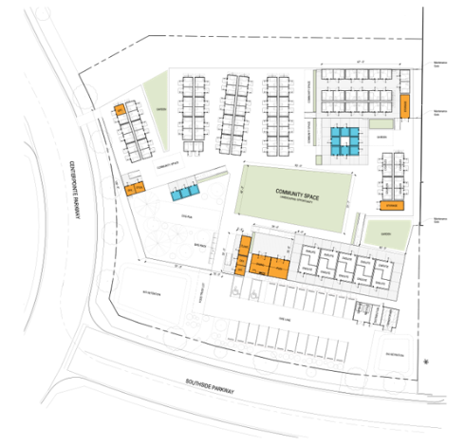
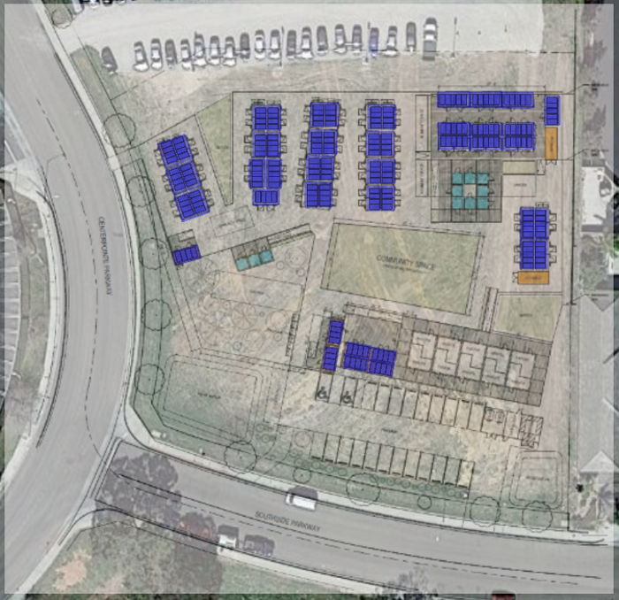

Figure 6: DignityMoves Santa Maria site plan and solar layout

Figure 6: DignityMoves Santa Maria site plan and solar layout

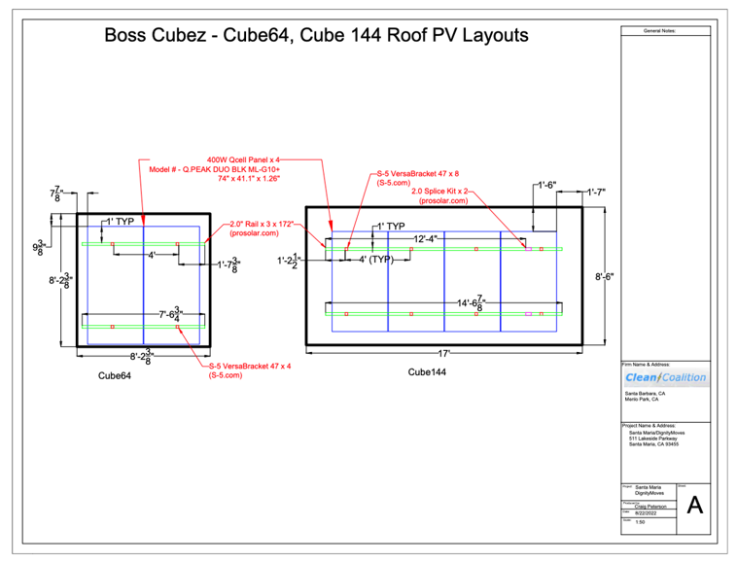
Figure 7: DignityMoves Santa Maria standardized solar design for each Boss Cubez unit

Sierra Blanca: To address limitations from the Imperial Irrigation District (IID) in meeting the planned Sierra Blanca community's electrical needs, Gatehouse Design and Developments engaged the Clean Coalition to design a solar-driven Community Microgrid solution. This innovative design equips each of the 34 all-electric homes with a dedicated Solar Microgrid, while a central Battery Energy Storage System (BESS) provides additional energy capacity and grid-forming for the overall community, ensuring self-sufficiency and total independence from the IID grid. The Clean Coalition's expertise in load profiling was instrumental in creating a bottoms-up load profile for each home – and subsequently for an aggregated community-wide load profile. The Clean Coalition used its Solar Microgrid and VOR123 Methodologies to optimize both cost savings and energy resilience for the entire solar-driven Sierra Blanca Community Microgrid.
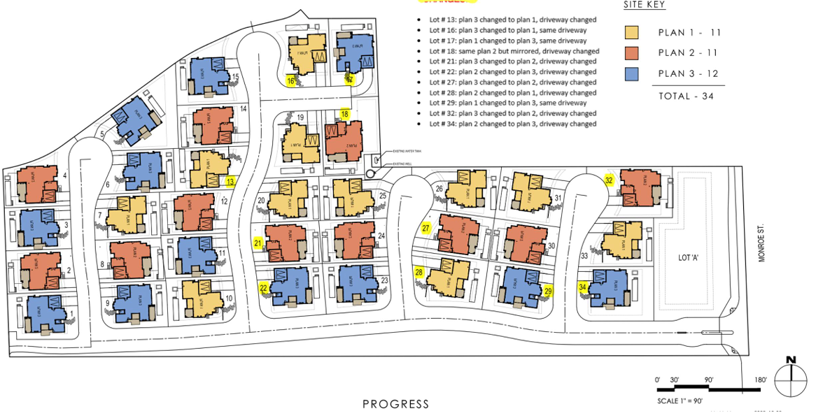
Figure 8: Sierra Blanca site plan

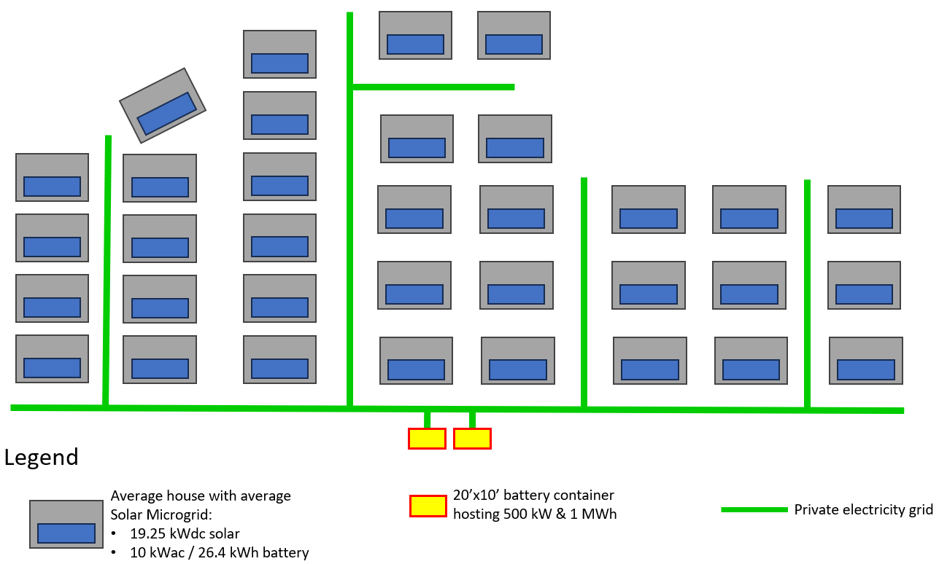
Figure 9: Sierra Blanca site layout and solar placement

Peninsula Advanced Energy Community (PAEC): PAEC provided an opportunity for the Clean Coalition to develop innovative, replicable approaches for accelerating the deployment of Advanced Energy Communities (AECs). Based on 25 megawatts (MW) of peak demand reduction, the initiative is anticipated to save energy consumers over $25 million, generate over $100 million in regional economic output, create $35 million in local wages, and reduce greenhouse gas emissions by nearly 800 million pounds over 20 years. Key AEC components in the PAEC Initiative:

- Abundant solar electricity, energy storage, and other distributed energy resources (DER)
- Low or zero net energy buildings
- Solar Emergency Microgrids for power management and support of critical facilities during outages
- Charging infrastructure to support the rapid growth of electric vehicles (EVs)

PAEC is supported by a broad range of collaborators, including Pacific Gas & Electric and numerous local governments, and was made possible by a grant through the CEC’s Electric Program Investment Charge (EPIC) program.

The Clean Coalition held multiple PAEC TAC meetings throughout the two and half years of the project’s performance period. These meetings were conducted either in-person or via webinar with participation and attendance levels ranging between 50-100+ individuals and from various parts of the industry, i.e.: local governments, utilities, schools, fire department, police department, business, and residents.

Alameda County Streamlining the Interconnection Process: The Clean Coalition partnered with Alameda County/East Bay Clean Energy (EBCE) to provide them with a Local Development Plan leveraging our PAEC work to perform a solar siting survey on the potential solar rooftop installation, feasibility analysis on solar+BESS potential installations, provide recommendations on streamlining the interconnection process, including stakeholder engagement to help Alameda County/EBCE understand the potential for constructing Distributed Energy Resource (“DER”) projects within EBCE’s service territory and within the 5-year planning horizon. This meant engaging with property owners identified as having the potential to build and/or host projects on their properties to develop a current and actionable understanding of their willingness to implement such projects within that timeframe. It also meant working closely with EBCE’s contractors and consultants to understand the EBCE portfolio and plans for procurement. To accomplish this effort, the Clean Coalition collected input from these key stakeholders through a cloud-based Survey Instrument combined with Focus Group and Workshop events, which provided an opportunity for a two-way flow of information to and from property owners.

Project Need
Identify the problem the project is intended to address.

A. How does your solution address issues, such as energy resiliency, greater affordability, or the environment? What are the proposed benefits for the targeted community?
The RGL Solar Microgrid project is designed to directly address the environmental and socioeconomic burdens that DACs like RGL face. Being situated within a disadvantaged census tract with high pollution scores and limited access to clean energy options, RGL residents already experience a disproportionate share of environmental hardships. Additionally, their location within the disaster-prone GLP region intensifies these burdens by making them more susceptible to power outages that disrupt essential services and can further strain already limited resources. This project offers a solution by not only providing clean energy and energy resilience, but also showcasing a standardized model that can be replicated in other DACs. Unlike wealthier communities that may have the resources to pursue individual Solar Microgrid solutions, this standardized Solar Microgrid design offers a chance for RGL to address their environmental and socioeconomic challenges.

The RGL Solar Microgrid project tackles critical issues for the targeted community through a comprehensive approach. By applying the Clean Coalition's established Solar Microgrid Methodology, the project will standardize a design using solar, energy storage, and load management. This project will also utilize the Clean Coalition’s VOR123 approach, to ensure indefinite resilience to the most critical loads at each residence.

Beyond the typical cost savings associated with solar energy generation, this project goes a step further to maximize long-term economic benefits for residents. The RGL Solar Microgrid will not only utilize energy arbitrage, peak demand shaving, and grid services facilitated by the BESS, but will also integrate the transition to all-electric appliances and Electric Vehicle Charging Infrastructure (EVCI) at each residence. This approach will enable residents to take advantage of the clean, reliable solar power generated by the microgrid, further reducing their dependence on the traditional grid and lowering their electricity bills for years to come.

Environmentally, the project aims for Net Zero Energy (NZE) for the community's Master Load Profile, which consists of the community’s historical load profile and future electrification adjustments. These electrification adjustments would include appliances like heat pump dryers, heat pump HVAC systems, hot water heat pumps, and EV charging stations. Currently, we estimate that the Master Load Profile will be 2x the size of the historical load profile. We also estimate that this will require around 1 MWdc of solar power distributed across veranda/carport structures, each supporting roughly 6 kWdc. This focus on clean energy generation is further amplified by the BESS. By strategically shifting solar energy to peak use periods, the BESS reduces reliance on the dirtier and costlier grid during those times, contributing to a cleaner environment. Moreover, the transition to all-electric appliances and EVCI within each residence will fully decarbonize individual homes. This aligns perfectly with California's ambitious goal to decarbonize the housing market, making RGL a model for sustainable communities.

Ultimately, the RGL Solar Microgrid project offers a "trifecta" of benefits for the targeted community. Residents will gain economic advantages through potentially lower energy bills, contribute to a cleaner environment through reduced greenhouse gas emissions, and experience increased resilience with a reliable backup power source during outages.

B. Identify Environmental Justice issues addressed by the project and describe the targeted community. Use demographic data to describe the environmental justice elements involved such as ethnicity; age distribution; median household income; size and ethnicity of immigrant populations; or geographic location. Cite your sources when using data.
The RGL Solar Microgrid project targets a disadvantaged community (DAC) facing environmental justice issues. These issues stem from a combination of significant environmental burdens and socioeconomic challenges that make the community more susceptible to the negative effects of pollution and climate change.

In May 2022, CalEPA released its updated designation of disadvantaged communities for the purpose of SB 535. In this designation, CalEPA formally designated four categories of geographic areas as disadvantaged:

- Census tracts receiving the highest 25 percent of overall scores in CalEnviroScreen 4.0 (CES 4.0) (1,984 tracts).
- Census tracts lacking overall scores in CES 4.0 due to data gaps, but receiving the highest 5 percent of CES 4.0 cumulative pollution burden scores (19 tracts).
- Census tracts identified in the 2017 DAC designation as disadvantaged, regardless of their scores in CES 4.0 (307 tracts).
- Lands under the control of federally recognized Tribes.
As shown in Figure 3, RGL is in census tract #6083003001, which has a CES 4.0 percentile of 76.8, qualifying the census tract as a DAC. It also happens to be the only DAC in the entire GLP region, putting this already marginalized community at risk of long-duration power outages. Situated east of the Santa Barbara Airport, adjacent and north of the La Goleta Gas Field, and west of agricultural land, it is no wonder that the census tract that RGL is in has the following percentile ranking relative to other census tracts, according to CES 4.0:

- Groundwater threats percentile of 96
- Hazardous waste percentile of 88
- Impaired waters percentile of 87
- Low birth weight percentile of 87
- Pesticide exposure percentile of 83
- Unemployment percentile of 83

In relation to the median household income of $84,097 in California, the census tract that RGL is in has an estimated median household income of $70,407, which falls into the 67 percentile for poverty according to CES 4.0 and making this census tract low-income community as shown in Figure 3 below from the California Climate Investment Priority Populations 2023 map.
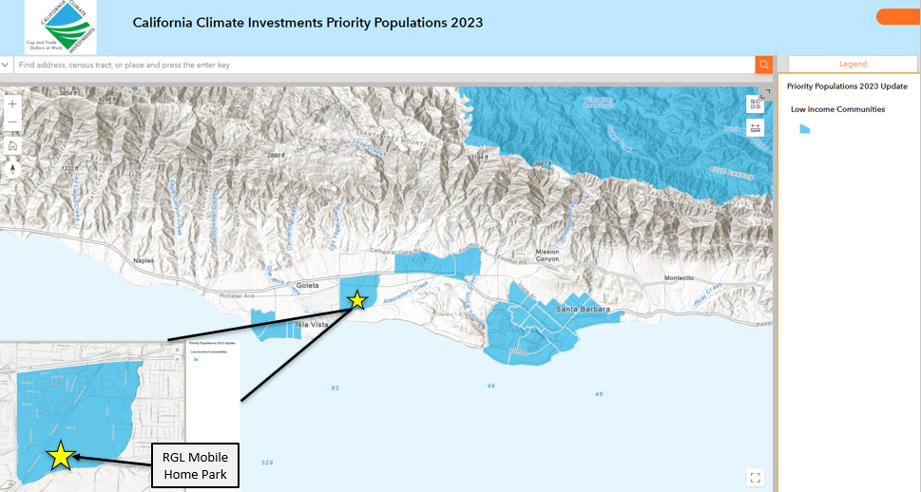
Figure 10: Rancho Goleta Lakeside Mobile Park, California Climate Priority Population map (yellow star is the RGL site location).

There are approximately 8,000 census tracts in California, which are made up of multiple census blocks, which are the smallest geographic unit for which population data is available. According to 2020 Census Demographic and Housing Characteristics, RGL is located in Block Group #060830030012, which has a very diverse population consisting of Hispanic or Latino, Black or African American, Asian, and other immigrant ethnicities. The RGL community itself has a population that is representative of the Block Group with an age range from senior to children, skewed to the senior size.

The Block Group consists of a wide range of ages with 22% being 65 and older, and a median age in the mid 40s.

C. How does the target community meet the eligibility rules for the clean energy program under consideration? If grant funds are used to pursue a MIP incentive, is the community vulnerable to outages and is it a disadvantaged or vulnerable community or does it have facilities serving such a community?
The RGL Solar Microgrid project is ideally suited for both the CEA Grant Program and the Self-Generation Incentive Program (SGIP) due to its location and community makeup.

Firstly, RGL resides in the sole DAC, as explained previously, census tract within the Goleta Load Pocket (GLP) region. This disadvantaged status, coupled with the GLP region's vulnerability to outages, makes RGL is a prime candidate for the CPUC's CEA Grant Programs, which prioritize disadvantaged communities seeking energy resilience.

Secondly, RGL qualifies for SGIP's equity rebate due to it being a small business organized as a nonprofit mutual benefit corporation and located within a disadvantaged community (DAC).

The Clean Coalition's expertise in technical and economic analysis for clean energy projects will be instrumental in ensuring the RGL Solar Microgrid meets all SGIP’s equity rebate requirements. Our comprehensive analysis will assess the Solar Microgrid’s technical viability and ensure all SGIP application documentation meets eligibility criteria.

By fulfilling these requirements and leveraging expert support, the RGL Solar Microgrid project is well-positioned to secure funding from both programs, bringing clean energy to the RGL community.

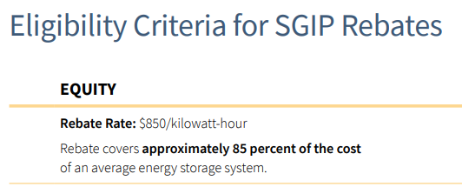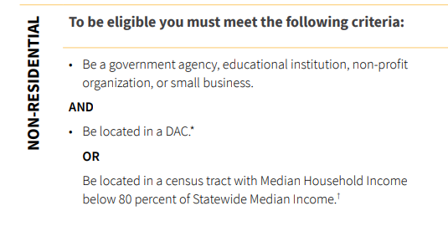
Figure 11: SGIP eligibility criteria for the non-residential Equity rebate

Evaluation and Data Collection

A. Define project goals and objectives. Identify desired outcomes for the targeted community.
The Table below outlines the RGL project goals and objectives:

Goals | Objectives | Desired Outcomes
Build awareness and educate stakeholders about the RGL Solar Microgrid project, ensuring inclusive and participatory planning. | Conduct community engagement sessions with support from a broad group of stakeholders with target inclusion from RGL residents, City of Goleta staff, County of Santa Barbara staff, outside community leaders, and representatives from other community-based organizations. | Full support for the RGL Solar Microgrid from all stakeholders, paving a way for a successful project and opportunities to proliferate more Solar Microgrids within DACs and beyond.
Develop a robust RGL Solar Microgrid technical & economic feasibility study. | Our Solar Microgrid Feasibility Study for RGL will delve into the limitations of their local grid, build detailed load profiles for planned electrification within each mobile home, determine the optimal sizing of the solar & BESS, and create efficient site layouts for each mobile home, likely on the veranda/carports. Additionally, we will conduct economic analyses and generate project reports that demonstrate the project's financial viability and overall value proposition. | A comprehensive technical and economic feasibility study that standardizes the solar and BESS designs at each mobile home and centralized BESS that provide grid-forming across the community, along with grid upgrade requirements -- leading to a comprehensive request-for-proposal (RFP) process.
Run a successful Request for Proposal (RFP) process that attracts competitive bids. | Streamline the RFP process by: 1) Leveraging the Solar Microgrid Feasibility Study to inform developers of the most optimal RGL Solar Microgrid design, 2) Utilizing past RFP processes by the Clean Coalition to ensure a smooth RFP process for RGL, and 3) Organizing an RFP scoring rubric for RGL and other key stakeholders in order to have a successful proposal selection process. | Contracting of the best Solar Microgrid proposer with the relevant technical expertise to develop and deploy the RGL Solar Microgrid, including any necessary grid upgrades.
Submit an application and receive the SGIP Equity rebate, as available. | Support the selected developer of the RGL Solar Microgrid in the SGIP application process. | Successful award of Equity SGIP funding for the RGL Solar Microgrid, which will in turn lower project costs and increase electricity bill savings for the RGL community.
Develop a compelling case study showcasing how Master Metering enhances both community resilience and economic well-being, paving the way for implementing Master Metering policy | Present RGL’s resilience and economic benefits in an easily understandable format, so policymakers will be well-equipped to make informed decisions regarding the implementation of Master Metering policy innovation. | 1) Master Metering policy innovations to enable the RGL Solar Microgrid benefits to accrue to any type of multi-unit housing (MUH) community.  2) Wide proliferation of Solar Microgrids at MUH community throughout California.

B. What baseline data will be used to establish a benchmark for evaluating the impact of the proposed program?
The baseline data used to establish benchmarks for evaluating the impact of the program will vary depending on the specific project management process and/or goal:

- Workplan: To monitor and evaluate each Task and their associated State Date and End Date, identify any schedule impacts of the proposed RGL Solar Microgrid, and identify solutions to resolve any impacts to ensure project success.
- Goal 1: Community Engagement and Education:
  - To ensure inclusive and participatory planning, baseline data will be collected through initial surveys distributed to RGL residents during awareness and education building sessions. These surveys will assess the following resident concerns:
    - Understanding of Solar Microgrids: This will gauge residents' familiarity with the technology and its potential benefits.
    - Power Outages: This will measure residents' level of concern regarding power disruptions and their impact on daily life.
    - Rising Electricity Rates: This will assess residents' concerns about the affordability of electricity.
    - Impact on Residences: This will address any worries residents may have about the potential effects of the Solar Microgrid on their homes.
- Goal 2: RGL Solar Microgrid Feasibility Study:
  - Baseline data will include:
    - Historical annual load data and associated SCE rates
    - Structural conditions of carports and permitting rules for solarizing them
    - Existing condition of the electrical infrastructure and its ability to accommodate solar, storage, all-electric appliances, and EV charging.
    - Any previous solar or Solar Microgrid proposals RGL has received from developers
  - This data will be assessed in order to inform the Solar Microgrid Feasibility Study and subsequent RFP process.
- Goal 3: Solar Microgrid RFP process:
  - Baseline data will consist of:
    - Data from installed Solar Microgrids of similar sizing and design, in which we can derive pricing from as a comparative measure between proposals.
- Goal 4: CPUC's SGIP Participation:
  - Baseline data is limited for this goal but would likely include:
    - Developer’s experience in applying for SGIP funds from previous projects that have been installed.
- Goal 5: Master Metering Case Study:
  - Baseline data will be the economic and resilience results from the RGL Solar Microgrid Feasibility Study, packaged into a Case Study.
C. What data collection methods will be used to measure the impact of the project on the targeted community?
The Clean Coalition will leverage a multi-pronged approach for data collection. This includes utilizing the Workplan’s framework, community engagement and education, implementation of our Solar Microgrid Methodology and its comprehensive data collection process.

The data collection methods used to measure the project's impact on the targeted community will vary depending on the specific goal:

- Goal 1: Community Engagement and Education:
  - Ongoing and post-implementation surveys: These surveys will be distributed to the same community as the baseline surveys and will assess the same aspects, tracking educational learning and sentiment.
    - Comparing the pre- and post-project survey results will show if the project increased awareness and addressed community concerns.
  - Ongoing webinars: GoToMeeting Webinar statistics tool will be used to track:
    - Webinar production details.
    - Attendance numbers.
    - Q&A participation during the webinars.
  - Events & Communications Tracker: To track media outreach & placement on op-eds and blog posts.
  - The Clean Coalition email mailing list can be used to track an increase in subscribers after webinars and media placements, indicating broader reach.
  - RGL Solar Microgrid landing webpage on the Clean Coalition’s website: To help track the number of visits to this site.
- Goal 2: RGL Solar Microgrid Feasibility Study:
  - Data collection methods for this goal will involve leveraging the results of the feasibility study, which will detail the economic, environmental, and resilience benefits for the RGL community.
- Goal 3: Solar Microgrid RFP process:
  - While directly measuring community impact isn't the sole focus of this goal, it remains a critical factor in selecting the winning RFP proposal. Data from each proposal will be meticulously evaluated based on predefined criteria, which will heavily weigh the potential benefits accruing to the RGL community.
- Goal 4: SCE's SGIP Participation:
  - This goal doesn't rely on data collection as the impact is binary - receiving a SGIP grant.
  - However, the feedback received from SCE throughout the application process can provide valuable insights into areas for improvement in future applications.
- Goal 5: RGL Master Metering Case Study:
  - The Case Study will provide a blueprint for Solar Microgrid proliferation at multi-residential communities – and for policy innovations that will streamline opportunities for future Solar Microgrids at such communities..

Finally, although the Clean Coalition is committed to maintaining the requested $150,000 grant budget, the Budget will also be another data collection method along with accounting records.

Community Engagement Plan
If the project has a community engagement component, describe how the applicant will engage the targeted community and involve them in the planning process and implementation process. Be sure to include details of specific staff and activities planned in your community engagement process in your Workplan.
The Clean Coalition prioritizes incorporating community voices into the RGL Solar Microgrid project. We will utilize various channels to solicit input, which will directly inform the project’s design and any County governed support programs. To achieve this, we’ll follow a two-step approach; securing County approval and fostering community engagement.

The first step involves a kickoff meeting with the RGL Board (upon receiving a CEA grant award) to present the project in detail and initiate collaboration. This collaborative effort, alongside the RGL Board, local experts, and regional partners, will focus on developing a comprehensive marketing and outreach plan. This plan has two key objectives: building awareness for the Solar Microgrid and educating the community about the microgrid’s economic and resilience benefits. The program implementation team will create targeted marketing materials highlighting these benefits. Additionally, a dedicated website will serve as a central information hub for the project.

In addition to the above efforts, the Clean Coalition plans to form a Technical Advisory Committee (TAC) composed of subject matter experts (SMEs) from the RGL Board, City of Goleta and Santa Barbara along with, other industry stakeholders who will provide their technical expertise in project design, equity, development, and implementation issues and solutions, including community engagement RGL community will be invited to TAC meetings giving them the opportunity to participate in the discussions on the aforementioned components of the project.

The role of the TAC will be to (1) review and provide the project team with critical community and expert feedback on project design, equity, development, and implementation issues and (2) to help the project team engage the community with regard to project design, equity, development, and implementation phases.

To ensure informed support, the project team will also conduct up to two educational webinars for City of Goleta staff, building managers, and the Technical Advisory Committee (TAC). These webinars will cover the overall project and relevant regulations, including the CPUC's Distributed Energy Resources (DER) and Microgrid Proceedings.

If the project has a technical assistance component, describe the process that will be used to find a qualified technical assistance provider as well as ensure that the technical assistance helps to overcome any gaps or barriers that the community or Tribe faces in accessing the SGIP.
The Clean Coalition will apply its long-standing Solar Microgrid Methodology and VOR123 to the RGL Solar Microgrid, with additional efforts to standardize a Solar Microgrid design in terms of solar, energy storage, and load management to maximize both bill savings and VOR. In addition to specifying functional requirements, the necessary materials will include detailed budgets and provide the basis for engaging installers to deploy all components of the RGL Solar Microgrid.

The RGL Board/CAC will be another technical resource offering their expert feedback on Project design, equity, development, and implementation issues and solutions.

Other technical assistance resources whose goals & objectives align with the project and the CPUC CEA Grant Program may also be sought. This includes soliciting technical assistance from Southern California Edison for their SGIP program.

Workplan
The goals as defined in the Table above under Evaluation and Data Collection section A align with Workplan (Appendix 7). However, as the Workplan template requires individual tasks per each goal including State Dates, End Dates, the performance measure and the expected outcome of each goal, due to this criteria and the maximum 20 page limit, this has been submitted as a separate attachment to the grant Application.

Budget
The Clean Coalition is requesting $150,000 in CEA grant funds to support its RGL efforts – full details are found in Appendix 8 that has been submitted as a separate attachment to the grant Application.

The Clean Coalition is committed to maintaining its CEA grant budget amount, if awarded. However, since the CPUC asks that the budget be allocated by Task, the Clean Coalition reserves the flexibility to shift budget allocations among tasks to address funding needs. The Clean Coalition also reserves the right to allocate additional staff resources to support any given Task activity to ensure progress and successful completion of the RGL project.

We understand that this amount is under the CPUC’s ministerial review and approval authority threshold and as such will only require an assigned CPUC staff to evaluate grant applications for eligibility, completeness, and score each application according to the Evaluation and Scoring Criteria as defined in the CPUC Equity & Access Grant Programs guidelines. It is also understood requested grant funds over $150,000, the Commission reserves discretion to address applications through a Resolution process, this includes post award budget amendment requests.

Clean Coalition’s value-of-resilience VOR123 website: Disaster resilience - Clean Coalition (clean-coalition.org)
Clean Coalition’s Portfolio of Experience: https://clean-coalition.org/wp-content/uploads/2022/02/Clean-Coalition-Portfolio-of-Experience-58_gy-07-Feb-2022.pdf
Clean Coalition DignityMoves website: https://clean-coalition.org/news/dignitymoves-santa-maria-solar-microgrid-standardized-design/
Clean Coalition’s Sierra Blanca Presentation: https://clean-coalition.org/wp-content/uploads/2024/04/Sierra-Blanca-Community-Solar-Microgrids-09_gy-24-Aug-2023.pdf
Clean Coalition’s PAEC website: https://clean-coalition.org/peninsula-advanced-energy-community/
Clean Coalition’s Alameda County Streamlining Interconnection Process website: https://clean-coalition.org/news/status-report-streamlining-interconnection/
CalEPA California Climate Investments to Benefit Disadvantaged Communities: https://calepa.ca.gov/envjustice/ghginvest/#:~:text=After%20receiving%20public%20input%20at%20workshops%20and%20in,designated%20four%20categories%20of%20geographic%20areas%20as%20disadvantaged%3A
United States Census Bureau's American Community Survey https://www.census.gov/programs-surveys/sis/resources/visualizations/acs.html
California Climate Investments Priority Populations 2023 map https://gis.carb.arb.ca.gov/portal/apps/experiencebuilder/experience/?id=6b4b15f8c6514733972cabdda3108348
CalEnviroScreeen 4.0 Report https://oehha.ca.gov/media/downloads/calenviroscreen/report/calenviroscreen40reportf2021.pdf
Census Demographic and Housing Characteristics https://www.census.gov/programs-surveys/decennial-census/decade/2020/planning-management/release/about-2020-data-products.html#dhc

